Chapter 3 Radioactivity and radiation

Chapter test Total marks 50

Name: Class: Date: __________

Section A (1 mark per question)

Question 1

Which of the following travels at the greatest speed?

A gamma radiation

B beta radiation

C alpha radiation

D they all travel at the same speed

Question 2

Which of the following best describes beta-minus radiation?

A energy emitted from an electron of an atom

B an electron ejected from an atom

C a helium nucleus emitted from an atom

D an electron emitted from the nucleus of an atom

Question 3

Which of the following options is the most penetrating form of radiation?

A gamma

B beta

C alpha

D none of the above

Question 4

Give the value of *x* in the following decay equation: .

A 238

B 236

C 234

D 232

*The following information relates to questions 5 and 6.*

Strontium-90 is one of the radioisotopes that was released during the Fukushima nuclear disaster in Japan. Strontium-90 has a half-life of 28.8 years.

Question 5

How many neutrons are there in each nucleus of strontium-90?

A 90

B 38

C 128

D 52

Question 6

If 1.8 × 1010 atoms of strontium-90 were released during the accident, how many of the original strontium-90 nuclides will still be in existence in 144 years?

A none

B 3.6 × 109

C 2.8 × 108

D 5.6 × 108

Section B

Question 7

a Rank the following forms of radiation from lightest to heaviest mass: (1 mark)

alpha, gamma, beta.

b Explain your answer to part a. (2 marks)

Question 8

a Rank the following forms of radiation from least ionising to most ionising: (1 mark)

beta, alpha, gamma.

b Explain your answer to part a. (2 marks)

Question 9

A radioactive sample of oxygen-15 has a half-life of 110 minutes. If the amount of oxygen-15 remaining after 5.5 hours is 0.80 g, calculate the mass of the original sample. (2 marks)

Question 10

In the following decay equations, what is the unknown, *X*?

**a**  (1 mark)

**b**  (1 mark)

**c**  (1 mark)

Question 11

When bombarded with neutrons, gold (Au-197) undergoes neutron absorption to become the radioactive isotope gold-198. Given that gold has an atomic number of 79, write a balanced equation for the following:

**a** the absorption of a neutron by a gold-197 atom (2 marks)

**b** the beta decay of a radioactive nucleus of gold-198. (2 marks)

Question 12

Cobalt-60 has a half-life of 5.3 years. A sample of pure cobalt-60 has a mass of 50 µg. How much of the cobalt-60 remains after:

**a** 10.6 years? (2 marks)

**b** 15.9 years? (2 marks)

**c** 17.5 years? (2 marks)

Question 13

Why is alpha radiation not used as a source in external radiotherapy treatment? (2 marks)

Question 14

An 85 kg man is exposed to 250 mJ of gamma radiation. Calculate:

**a** his absorbed dose (1 mark)

**b** his dose equivalent (1 mark)

**c** his dose equivalent if he had been exposed to 250 mJ of alpha radiation instead (1 mark)

**d** the energy of the radiation he is exposed to in electronvolts (eV). (1 mark)

Question 15

A doctor prescribes a course of radiotherapy for a patient with breast cancer. The procedure involves inserting a radioactive source into the affected region. Explain which type of radiation source—alpha, beta-minus or gamma—the doctor should use, and why. (4 marks)

Question 16

A scientist uses a Geiger counter to measure the radiation of a radioactive sample. She records the count as 90 000 emissions per minute.

**a** Calculate the activity of the sample in becquerel (Bq). (1 mark)

**b** It takes 1.5 hours for a 120 µg sample of the radioisotope to decay to 15 µg.   
Calculate the half-life of the sample in minutes. (3 marks)

Question 17

The radioactive decay of a particular isotope is shown on the graph below. The initial mass of the radioisotope is 40 g.

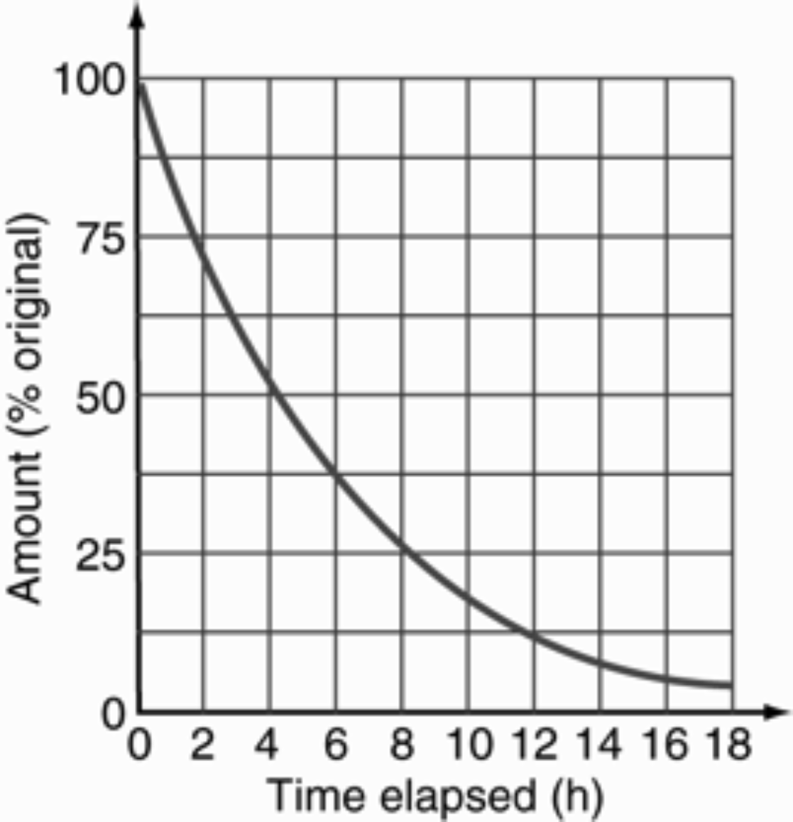

**a** Find the time it takes for a 40 g sample to decay to 10 g. (2 marks)

**b** Find the half-life of the sample. (1 marks)

**c** From the graph, find how much of the original radioisotope (in grams) remains after 10.0 hours.

(2 marks)

Question 18

aA scientist is using a Geiger counter to examine a locked box made of very thin aluminium. The Geiger counter detects some radiation being emitted through the top of the box. Without opening the box, the scientist puts a thick sheet of aluminium around the box and finds that the activity registered by the Geiger counter reduces. What type(s) of radiation could be present? (Assume neutrons are not present.) (2 marks)

b The scientist then puts a strong magnetic field across the box. She finds that the direction of the radiation changes and there is no radiation in the original direction. What type of radiation is it, and why? (2 marks)